**DISABLED ACCESS UPGRADE**

**COMPLIANCE CHECKLIST PACKAGE**

**(For Existing Buildings only)**

Updated 02/28/2019



This package contains:

1. Instructions
2. Important Notification
3. City Projects – Department of Public Works
4. City Projects – Mayor’s Office on Disability
5. Disabled Access (D.A.) Checklist (2 pages)
6. Form C: Disabled Access 20% Rule
7. Form F: Projects that consist only of Barrier Removal, Notice of Accessibility Violation (NOV) Compliance, or Exempted Work.
8. Approval of Equivalent Facilitation Request (2 pages)
9. Approval of Technical Infeasibility Request
10. Unreasonable Hardship Request Form (2 pages)

Note: This checklist is available in MS-Word & PDF format at our website: [www.sfdbi.org](http://www.sfdbi.org) > Most Requested > Forms & Handouts

Disabled Access Compliance Checklist

Instructions

**Step 1: Completely fill out both pages of the Disabled Access (D.A.) Checklist & check all appropriate boxes.**

Also, fill out any additional forms as specified on the D.A. Checklist. **If you are submitting a revision** to a previously approved permit, then fill out p. 1 of the D.A. Checklist only (Note: a revision is considered to be a slight modification to the original approved permit drawing set, not new or additional work). The original approved plans (or a copy of the original) are required to be brought back for reference in addition to 2 sets of the proposed revisions.

**Step 2: A. If your project is over the threshold and all existing conditions comply with current regulations:**

Check box A on page one, and check all items as fully complying in column 1 of page 2.

**B. If your project is over the threshold and not all existing conditions comply with current regulations:**

Check the appropriate box in columns 2 through 7 of page 2, and fill out any required forms as indicated at the bottom of the page.

**If you are providing an equivalent facilitation,** fill out and attach the Request for Approval of an Equivalent Facilitation form. Upon approval, the equivalent facilitation is regarded as code compliant.

**If you are claiming a technical infeasibility,** fill out and attach the Request for Approval of an Technical Infeasibility form. Upon approval, the technical infeasibility is regarded as code compliant provided you comply with the code requirements to the maximum extent feasible.

**If any of the elements of the path of travel have been altered constructed or altered in compliance with the immediately preceding edition of the code (2013 CBC**), but do not meet the incremental changes of the current edition; check the appropriate box in column 5 and provide details as specified.

**If an accessible element is non-existent and is not required,** check the appropriate box in column 6.

**If full compliance with current regulations would create an unreasonable hardship** due to financial constraints, check the appropriate box(s) in column 7 and fill out and attach an Unreasonable Hardship Request (UHR) form. The Department will review then grant or deny your request. **The Access Appeal Commission must ratify all approved UHRs**. A UHR that is denied may be appealed to the Access Appeals Commission.

**(See page _____ for details on how to send ratification request or appeal to the AAC.)**

**C. If your project is under the current valuation threshold:**

Check box C on page 1 of the DA checklist. Fill out and attach Form C - the 20% Rule. List all items that will be brought into compliance on form C. The valuation of items on form C should be as close as possible to 20% of the adjusted cost of construction, but is never required to exceed that amount. All items that will not be brought into compliance due to the cost exceeding the 20% limit should be checked on page 2 of the checklist in column 6.

**Any work that is within the scope of the alteration or addition itself must comply with all of the requirements of CBC chapter 11B unless specifically exempted by regulation.**

**Step 3: Is this a City Project?**

**City Projects** are buildings or sites that are owned, leased, or funded by the City of San Francisco. Examples include but are not limited to City offices and clinics, City occupied leased spaces, libraries, parks, playgrounds including those built by philanthropic groups on City land, publicly funded affordable housing, and community development projects. Funding sources include but are not limited to General Obligation Bonds, General Funds, RPD Community Opportunity Fund, MOH and MOHCD, OEWD, and State or Federal grants issued to the City.

If your project is not a **City Project**, skip to Step 4.

**City Projects** must be reviewed by either the Mayor’s Office on Disability (MOD) or the DPW Disability Access Coordinator (DPW DAC). DPW DAC reviews projects designed, managed, or built by DPW. MOD reviews the rest including publicly funded affordable housing. A signed copy of either the MOD or DPW Disability Access Compliance project sign-off form (as appropriate) shall be reproduced on the cover sheet of the plans. For projects that have a sequential review, plans will not be accepted by DBI without prior review with documented sign off from the appropriate access compliance agency (MOD or DPW). For projects submitted under a parallel review process, then MOD or DPW must receive the plans at the same time as the other permit review agencies, and subsequent revisions must be coordinated. If you have questions about a City Project, or want to know whether MOD or DPW or will be responsible for the accessibility review, or how to obtain forms, please contact MOD at 415 554-6789, MOD@SFGOV.org or review the MOD plan check procedures at [www.sfgov.org/mod](http://www.sfgov.org/mod).

**Step 4: Submittal.** Be sure to clearly describe all work on the permit application and follow all instructions as above. Submit permit application and plans to the Department of Building Inspection.

**IMPORTANT NOTIFICATION**

# I. Construction Cost - Field Conditions

1. Construction cost shall be based on the DBI Cost Schedule. DBI may accept bona-fide contract prices upon review and approval.
2. The cost is used to determine the level of disabled access upgrade to the path of travel to the specific area of alteration or addition. In general, forprojects with construction costs (excluding accessibility upgrades to the path of travel leading to the specific area of alteration or addition) equal to or belowthe valuation threshold (based on the Engineering News Report –ENR- US 20 Cities Average Construction Cost Index—currently **$150,244.00**). The cost of providing an accessible path of travel to the specific area of alteration or remodel shall be limited to 20% of the adjusted construction cost.

Projects exceeding the valuation thresholdare required to provide a fullyaccessible path of travel to the specific area of alteration or addition*.* Upgrades required by section 11B-202.4 to the elements of the path of travel to the specific area of remodel, or addition shall include the primaryentrance~~s~~ (as defined in chapter 2 section 202), restrooms, drinking fountains, public telephones and signs serving the area of remodel or addition. Full compliance or equivalent facilitation shall be provided unless doing so will create an unreasonable hardship. In the case where compliance will create an unreasonable hardship, the path of travel shall be made accessible to the maximum extent possible, but in no case shall the cost of compliance be less than 20% of the adjusted construction cost.

Note: For Alterations only, when the Department determines that compliance with applicable requirements is technically infeasible (as defined in chapter 2, section 202), the element(s) deemed infeasible shall be considered as compliant with the code.

1. Construction cost will be verified during plan check and inspection stages by DBI. In the event that the cost has to be adjusted above the valuation threshold, then the design may be required to provide full disabled access compliance.
2. The design professional shall verify existing field conditions and confirm that the information provided on the plans is accurate to the best of his/her knowledge. A DBI Field or District Inspector may issue a Stop Work Order or Correction Notice if the plans do not reflect the actual field conditions.

**II. Americans with Disabilities Act (ADA)**

Two federal laws, the Americans with Disabilities Act (ADA) and the federal Fair Housing Act, are currently in effect. They impose new federal disability access requirements on construction projects. DBI does not enforce federal law and will not be checking plans for compliance with these requirements. It is your responsibility to make sure that your plans are in conformance with federal law.

For information concerning the ADA, contact the Architectural Transportation Barrier Compliance Board at 1-800-872-2253 or the Department of Justice at 1-800-514-0301.

For information concerning the Fair Housing Act, contact HUD at 1-415-436-6551.

# III. Curb Ramps, Sidewalks, or Other Work within the Public Way

If the project includes the reconstruction of a sidewalk, a curb ramp may be required. Curb ramps shall be constructed at each corner of street intersections and where a pedestrian way crosses a curb. In the event that the project triggers requirements for a curb ramp, the permit application will be routed to the Department of Public Works, Bureau of Engineering (DPW). Under certain circumstances, a minor sidewalk encroachment may be required. A Certificate of Final Completion will not be issued for the project until DPW confirms that required curb ramps have been completed. Contact DPW at (415) 558-6060.

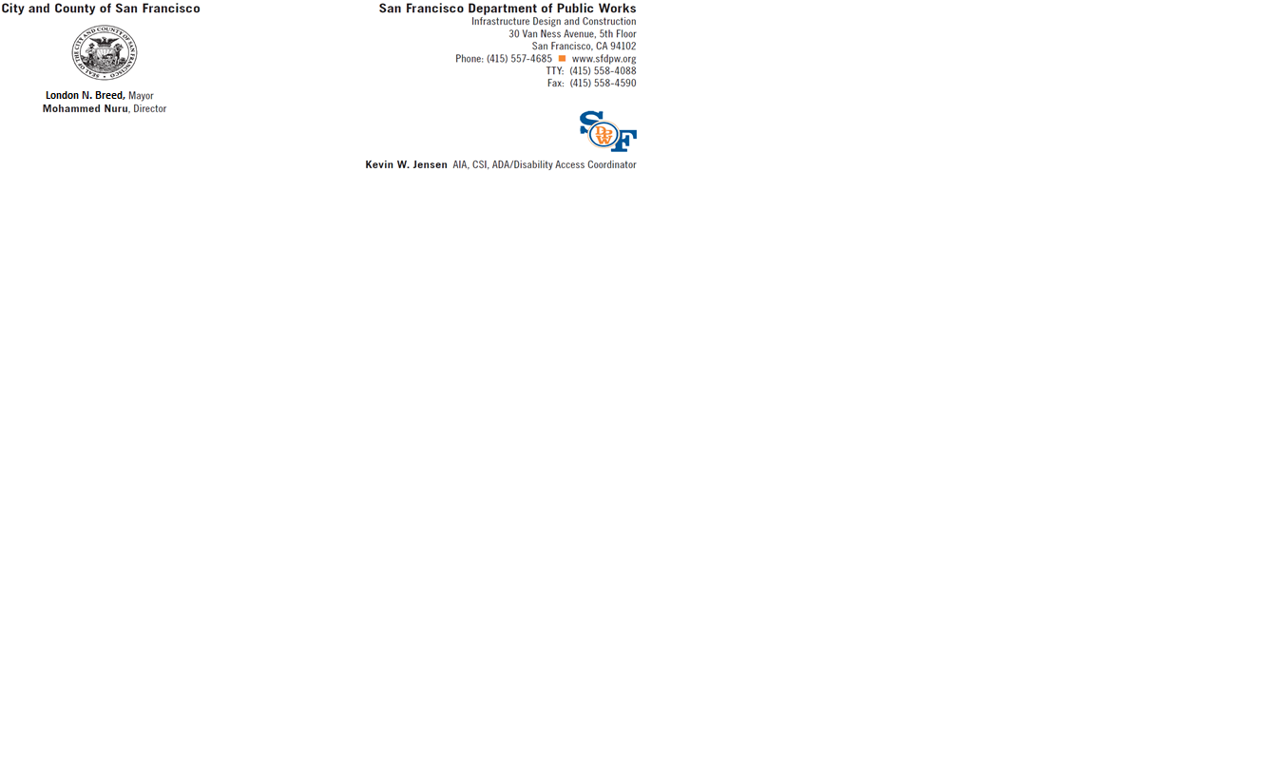

**DISABILITY ACCESS COMPLIANCE FOR CITY FUNDED PROJECTS**

Applicant: Fill in project name and address and then scan onto plans.

PROJECT: 

Project Address: 

**Leave Area Below Blank – For DAC Staff Use Only**

**PLAN REVIEW STAGE:** DPW-DAC has approved:

☐ Unreasonable Hardship / technically infeasible Date: 

☐ Playground ADA Inventory Form Date: 

☐ Pre-application review / site permit Date: 

☐ Final Construction Plan Date: 

**INSPECTION STAGE:** The following inspections are required, if selected. Call DAC at 557-4685 to schedule:

☐ Pre-Construction Conference

☐ Rough framing, after plumbing and electrical rough is complete

☐ Mock up inspection of bathrooms / kitchens

☐ Demonstration of adaptable cabinetry

☐ Signage, including proofs and color samples prior to fabrication

☐ Door closer pressure and timing

☐ Power door operator testing per BHMA A156.19

☐ Playground equipment, surface, and path of travel

**☐ Final Signoff of Project**

**The following additional documents are required:**

☐ Reasonable Accommodation Notices

☐ Signage approval from Lighthouse for the Blind

☐ Illustrated instruction manual to adapt unit interiors

☐ Inspection matrix listing each covered dwelling unit or common space

 

By: Kevin Jensen Date:

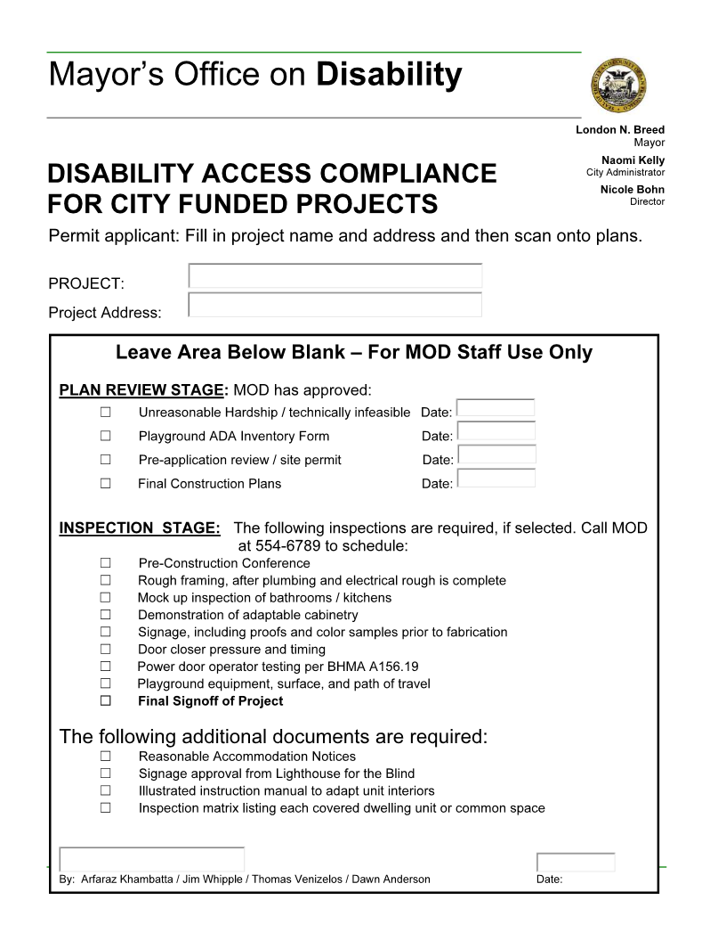

~ 5 ~

**D.A. CHECKLIST** (p. 1 of 2): The address of the project is: _______________________________

*For ALL tenant improvement projects in commercial use spaces, both pages of this checklist are required to be reproduced on the plan set and signed.*

**1.** The proposed use of the project is _______________________________________ (e.g. Retail, Office, Restaurant, etc.)

**2.** Describe the area of remodel, including which floor: _______________________________________

**3.** The construction cost of this project *excluding* disabled access upgrades *to the path of travel is* **$__________________**, which is; *(check one)*  more than /  less than the 2019 Valuation Threshold of **$166,157.00**.

**4.** Is this a City project and/or does it receive any form *of* public funding? *Check one:*  Yes /  No Note: If Yes, then see Step 3 on the Instructions page of the Disabled Access Upgrade Compliance Checklist package for additional forms required.

***Conditions below must be fully documented by accompanying drawings***

**5.** Read **A** through **D** below carefully and check the most applicable boxes. Check one box only:

|  |
| --- |
| **◻ A:** All existing conditions serving the area of remodel fully comply with access requirements. No further upgrades are required:  Fill out page 2 of D.A. Checklist |
| **◻ B:** Project Adjusted cost of construction is greater than the current valuation threshold:  Fill out and attach page 2 of D.A. Checklist and any other required forms to plans |
| **◻ C:** Project adjusted cost of construction is less than or equal to the current valuation threshold:  List items that will be upgraded on Form C. All other items shall be checked on page 2 of the D.A. Checklist in the “Not required by code” column. |
| **◻ D:** Proposed project consists entirely of Barrier removal:  Fill out and attach Barrier removal form to Plans |
| **◻ E:** **Proposed project is** minor revision to previously approved permit drawings only. (Note: This shall NOT be used for new or additional work) Provide previously approved permit application here: _______________________________. Description of revision: ____________________________________________________________________ |

CBC chapter 2 section 202 Definitions:

**Technically Infeasible**. An alteration of a building or a facility, that has little likelihood of being accomplished because the existing structural conditions require the removal or alteration of a load-bearing member that is an essential part of the structural frame, or because other existing physical or site constraints prohibit modification or addition of elements, spaces or features that are in full and strict compliance with the minimum requirements for new construction and which are necessary to provide accessibility.

**Unreasonable Hardship.** When the enforcing agency finds that compliance with the building standard would make the specific work of the project affected by the building standard infeasible, based on an overall evaluation of the following factors:

1. The cost of providing access.
2. The cost of all construction contemplated.
3. The impact of proposed improvements on financial feasibility of the project.
4. The nature of the accessibility which would be gained or lost.
5. The nature of the use of the facility under construction and its availability to persons with disabilities

*The details of any Technical Infeasibility or Unreasonable Hardship shall be recorded and entered into the files of the Department. All Unreasonable Hardships shall be ratified by the AAC.*

**D.A. CHECKLIST** (p. 2 of 2): The address of the project is :_______________________________

***Check all applicable boxes and specify where on the drawings the details are shown:***

|  |  |  |  |  |  |  |  |  |
| --- | --- | --- | --- | --- | --- | --- | --- | --- |
| Note: upgrades below are listed in priority based on CBC11B-202.4,  exception 8 | **Existing Fully Complying** | **Will be Up-graded to Full**  **Compliance** | **Equivalent facilitation will provide full access** | **Compliance is Technically infeasible** | **Approved in compliance with immediately preceding code** | **Not required by Code (and/or none existing)** | **Non-compliant request URH Must be ratified by AAC** | Location of detail(s)-include detail no. & drawing sheet *(do not leave this part blank!).* Also clarification comments can be written here. |
| 1. One accessibleentrance including: approach walk, vertical access, platform (landings), door / gate and hardware for door/gate | ◻ | ◻ | ◻ | ◻ | ◻ | ◻ | ◻ |  |
| 1. An accessible route to the area of remodel including:   Parking/access aisles and curb ramps  Curb ramps and walks  Corridors, hallways, floors  Ramps elevators, lifts | ◻  ◻  ◻  ◻ | ◻  ◻  ◻  ◻ | ◻  ◻  ◻  ◻ | ◻  ◻  ◻  ◻ |  | ◻  ◻  ◻  ◻ | ◻  ◻  ◻  ◻ |  |
| C. At least one accessible restroom for each sex *or a* single unisex restroomserving the area of remodel. | ◻ | ◻ | ◻ | ◻ | ◻ | ◻ | ◻ |  |
| D. Accessible public pay phone. | ◻ | ◻ | ◻ | ◻ | ◻ | ◻ | ◻ |  |
| E. Accessible drinking fountains. | ◻ | ◻ | ◻ | ◻ | ◻ | ◻ | ◻ |  |
| F. Additional accessible elements such as parking, stairways, storage, alarms and signage. | ◻ | ◻ | ◻ | ◻ | ◻ | ◻ | ◻ |  |
| See the requirements for additional forms listed below | 1. | 2. | 3. | 4. | 5. | 6. | 7. |  |
|  |  |  |  |  |  |  |  |  |

No additional forms required

No additional forms required

Fill out Request for Approval of Equivalent Facilitation form for each item checked and attach to plan.

Fill out Request for Approval of Technical Infeasibility form for each item checked and attach to plans.

Provide details from a set of City approved reference drawings, provide its permit application number here:___________________________ and list reference drawing number on plans.

No additional forms required

Fill out Request for an Unreasonable Hardship form for each item checked and attach to plan. All UHR must be ratified by the Access Appeals Commission (see UHR form for details)

Form C: DISABLED ACCESS 20% RULE

This form is only required for projects equal to or under the valuation threshold when box “C” is checked off on the D.A. Checklist and is for providing an itemized list of the estimated costs for the expenditures used for disabled access upgrades for this project. Reproduce this form along with the D.A. Checklist and any required form(s) on the plans.

Based on CBC Section 11B-202.4 Exception 8, only projects with a construction cost less than or equal to the valuation threshold (current ENR Construction Cost Index Amount) are eligible for the 20% rule. In choosing which accessible elements to provide, priority should be as listed on p. 2 of the D.A. Checklist.

In general, projects valued over the threshold are not eligible for the 20% rule (see CBC 11B-202.4 Exceptions1 through 8for other exceptions).

CBC Section11B*-*202.4, Exception 9 *(abbreviated):* In alteration projects involving buildings & facilities previously approved & built without elevators, areas above & below the ground floor are subject to the 20% disproportionality provisions described in Exception 8, even if the value of the project exceeds the valuation threshold in Exception 8. Refer to the Code for the types of buildings & facilities that qualifies for this 20% disproportionality provisions when project valuation is over the threshold.

|  |  |  |  |  |
| --- | --- | --- | --- | --- |
|  |  | **Contractor’s Estimated Cost** |  | **DBI Revised Cost** |
| **A) Cost of Construction:**  (Excluding Alterations to the Path of Travel as required by 11B-202.4) |  | $ |  | $ |
| **B) 20% of A) :** |  | $ |  | $ |
|  |  |  |  |  |
| **List the Upgrade Expenditures and their respective construction cost below:** | | | | |
| 1. |  | $ |  | $ |
| 2. |  | $ |  | $ |
| 3. |  | $ |  | $ |
| 4. |  | $ |  | $ |
| 5. |  | $ |  | $ |
| 6. |  | $ |  | $ |
| 7. |  | $ |  | $ |
| 8. |  | $ |  | $ |
| 9. |  | $ |  | $ |
| 10. |  | $ |  | $ |
| 11. |  | $ |  | $ |
| 12. |  | $ |  | $ |
|  |  |  |  |  |
| **Total Upgrade Expenditures**  Should be approximately equal to, but not to exceed**,** Line B |  | $ |  | $ |

##### Form F: Consisting Only of Barrier Removal, Notice of Accessibility Violation Compliance, or Exempted Work

*Reproduce this Form on the plan set. Check box I, II, or III. If checking box I, check all other appropriate boxes in section I.*

* **I. Barrier Removal Work (Section 11B-202.4, Exception 3 and 4).**

Note: Barrier removal only projects shall be limited to the scope of work only and shall not be required to comply with section 11B-202.4 (Path of travel requirements).

Alterations, or additions consisting of one or more of the following shall be limited to the actual work of the project *(check all that applies):*

* Altering one building entrance to meet accessibility requirements.
* Altering one existing toilet facility to meet accessibility requirements.
* Altering existing elevators to meet accessibility requirements.
* Altering existing steps to meet accessibility requirements.
* Altering existing handrails to meet accessibility requirements.
* Alteration solely for the purpose of removing barriers undertaken pursuant to the requirements of Sections 36.402 and 36.404 through 36.406 of Title III of the Department of Justice regulations promulgated pursuant to the Americans with Disabilities Act (Public Law 101-336, 28 C.F.R. Section 36.402, 28 C.F.R. Section 36.404, 28 C.F.R. Section 36.405, 28 C.F.R. Section 36.406), included but not limited to:

1. Installing ramps
2. Making curb cuts in sidewalks and entrances
3. Repositioning telephones or shelving
4. Adding raised markings on elevator control buttons
5. Widening doors
6. Installing grab bars in toilet stalls
7. Rearranging toilet partitions to increase maneuvering space
8. Creating designated accessible parking spaces
9. Adding raised markings on elevator control buttons
10. Installing accessible door hardware
11. Installing flashing alarm lights
12. Insulation lavatory pipes
13. Repositioning paper towel dispenser in a bathroom
14. Installing a full length bathroom mirror
15. Others upon approval of building official

Description of others:

________________________________________________________________________________________________________________________________________________________________________________________________

* **II. Exempted Work (Section 11B-202.4, Exception 5 and 6);**

Alterations of existing parking lots by resurfacing and/or restriping; and the addition of or replacement of signs and/or identification devises shall be limited to the actual scope of work and shall not be required to comply with section 11b-202.4

* **III. Exempted Work (Section 11B-202.4, Exception 7)**

“Projects which consist only of heating, ventilation, air conditioning, re-roofing, electrical work not involving the placement of switches and receptacles, cosmetic work that does not affect items regulated by this code, such as painting, carpeting, etc., are not to be part of the architecture of the building or area…unless they affect the usability of the building or facility.”

**APPROVAL OF EQUIVALENT FACILITATION REQUEST**

*For Projects* ***with an Adjusted Construction Cost******Exceeding the Current Valuation Threshold*** *and Requesting* Approval of a designs, products or technologies alternative to the prescriptive details of the Disabled Access Regulations

as per CBC section *11B-103*

1. Site Address: 2. Floor:

3. Permit Application No.: 4. Request No.:

5. Existing Use: 6. Proposed Use:

7. Existing Occupancy: 8. Proposed Occupancy:

9. Description of proposed work or path of travel upgrade for which equivalent facilitation is requested:

CBC 11B-103, nothing in these requirements prevents the use of designs, products, or technologies as alternatives to those prescribed, provided they result in substantially equivalent or greater accessibility or usability. See CBC Chapter 2, section 202; *Equivalent Facilitation*

We request that the following be approved as an equivalent facilitation to the prescriptive regulations. This equivalency will provide equal or greater accessibility and usability. This equivalency provides for the maximum independence of the persons with disabilities while presenting the least risk of harm injury or other hazards to such persons or others.

10. Detailed description of the requested equivalency. (Provide details, documents and drawings if required)

11. This Equivalent Facilitation is addressed by:

 Information Sheet DA-_____________  Administrative Bulletin AB-______________

 AB-005 Local Equivalency

 Other _____________________________________________________________________________

Note: Ratification by the Access Appeals Commission **is not** required for Equivalent Facilitation Request.

12. Applicant’s Name (Print):

 Owner  Tenant  Agent

Applicant’s Signature: ______________________________________________

13. Applicant’s Address:

14 Applicant’s Phone: _______________________ Applicants Email: ________________________________________

**APPROVAL OF EQUIVALENT FACILITATION REQUEST (page 2)**

FOR THE DEPARTMENT OF BUILDING INSPECTION STAFF USE ONLY

***This equivalent facilitation request is:***

❑ ***APPROVED***  ***DENIED***

Plans reviewed by (print name):

Signature of the Plans Examiner: _______________________________________ Date: _____________________

**Approved** for the following reason(s):

**Denied** for the following reason(s):

*Signature of the Group Supervisor: ______________________________________ Date: ____________________

*(needed only when Denied)

If your Request for Approval of Equivalent Facilitation has been denied, the plans examiner shall inform you of the reasons for denying that request. In addition, the plans examiner’s group supervisor shall provide you with a second opinion regarding the denial.

If your Request for Approval of Equivalent Facilitation has been denied, you may file an appeal with the Access Appeals Commission. Please refer to the Access Appeals Commission Information Guide, available at the Customer Services desk, for complete information on this process.

Please submit appeals in person to: Secretary, Access Appeals Commission

1660 Mission Street, 1st Floor

San Francisco, CA 94103

(415) 558-6110

**APPROVAL OF TECHNICAL INFEASIBILITY REQUEST**

*To be used where it is technically infeasible to meet the prescriptive requirements of the code within the scope of work of an alteration or within an existing path of travel to the area of work of an alteration or addition.*

as per CBC section *11B-202.3*

1. Site Address: 2. Floor:

3. Permit Application No.: 4. Request No.:

5. Existing Use: 6. Proposed Use:

7. Existing Occupancy: 8. Proposed Occupancy:

9. Description of proposed alteration element or path of travel upgrade for which technical infeasibility approval is requested:

CBC 11B-202.3, In alterations, where the enforcing authority determines compliance with applicable requirements is technically infeasible, the alteration shall provide equivalent facilitation or comply with the requirements to the maximum extent feasible. See CBC Chapter 2, section 202; *Technically Infeasible*

10. This alteration is technically Infeasible due to:

❑ It would require removal or alteration of a load bearing member that is an essential part of the structural frame

❑ other existing physical or site constraints

11. Detailed description of the technical infeasibility. (provide details, documents and drawings if required or requested by staff)

_______________________________________________________________________________

____________________________________________________________________________________________________

____________________________________________________________________________________________________

1. Compliance with the regulations will be provided to the maximum extent feasible; (give description) _____________

____________________________________________________________________________________________________

____________________________________________________________________________________________________

____________________________________________________________________________________________________

(For the re-use of this form.) I have verified that the above stated compliance is still in effect and is the maximum degree of compliance possible. Applicant initials ___________ and date ____________.

13. Applicant’s Name (Print):

❑ Owner  Tenant  Agent

Applicant’s Signature: ___________________________________________________

14. Applicant’s Address:

15. Applicant’s Phone: _______________________ Applicants Email: _______________________________________

**APPROVAL OF TECHNICAL INFEASIBILITY REQUEST (page 2)**

FOR THE DEPARTMENT OF BUILDING INSPECTION STAFF USE ONLY

***This technical infeasibility request is:***

❑ ***APPROVED (FOR THIS PERMIT ONLY)***  ***DENIED***

Plans reviewed by (print name):

Signature of the Plans Examiner: _______________________________________ Date: _____________________

**Approved** for the following reason(s):

**Denied** for the following reason(s):

*Signature of the Group Supervisor: ______________________________________ Date: ____________________

Approved for re-use Supervisor initials __________ and Date____________.

If your Request for Approval of Technical Infeasibility has been denied, the plans examiner shall inform you of the reasons for denying that request. In addition, the plans examiner’s group supervisor shall provide you with a second opinion regarding the denial.

If your Request for Approval of Technical Infeasibility has been denied, you may file an appeal with the Access Appeals Commission. Please refer to the Access Appeals Commission Information Guide, available at the Customer Services desk, for complete information on this process.

Please submit appeals in person to: Secretary, Access Appeals Commission

1660 Mission Street, 1st Floor

San Francisco, CA 94103

(415) 558-6110

**UNREASONABLE HARDSHIP REQUEST**

**For Projects with an Adjusted Construction Cost Exceeding the Current Valuation Threshold and Requesting Exceptions to Disabled Access Regulations as per section 11B 202.4 exception 8, Title 24 (Page 1 of 2)**

1. Site Address: 2. Floor:

3. Permit Application No.: 4. Hardship Request No.:

5. Existing Use: 6. Proposed Use:

7. Existing Occupancy: 8. Proposed Occupancy:

9. Description of proposed work which triggers access compliance upgrades:

CBC Section11B-202.4, exception 8. When the adjusted construction cost exceeds the current valuation threshold, and the Department determines that the cost of compliance with section 11B-202.4 is an unreasonable hardship …full compliance shall not be required. Compliance shall be provided by equivalent facilitation or to the greatest extent possible without creating an unreasonable hardship. In no case shall the cost of compliance be less than 20% of the adjusted construction cost.

We request that this project be granted an exception from the following specified requirements of Title 24 Part 2 of the California Code of Regulations because compliance would create an unreasonable hardship as defined in Section 202 of Title 24.

10. The access feature(s) that will not be provided is (are) :

 a. Accessible Entrance.  b. An accessible route to the area of remodel.

 c. Accessible restrooms.  d. Accessible public pay phones.

 e. Accessible drinking fountain.  f. Accessible signage.

 g. Visual alarms, storage and additional parking.

1. Detailed description of the accessible feature(s) that will not be provided. What is the condition now? Note location on the plans or provide attachments if necessary.

1. Total adjusted cost of construction for the project:
2. A. Cost of the accessible feature(s), which will not be provided:
3. Percentage of total cost shown on Line 12 (divide line 13 by line 12):

14. Reference drawings and give a description of how compliance will be provided to the maximum extent possible:

__________________________________________________________________________________________________________________________________________________________________________________________________________________________________________

Note: Ratification by the Access Appeals Commission is required for all Unreasonable Hardship Requests. Refer to the 2016 California Building Code Section 11B-202.4 Exception 8.

**UNREASONABLE HARDSHIP REQUEST** (Page 2 of 2)

15. Applicant’s Name (Print):

 Owner  Tenant  Agent

Applicant’s Signature:

16. Applicant’s Address:

FOR THE DEPARTMENT OF BUILDING INSPECTION STAFF USE ONLY

***This exception for unreasonable hardship is:***

❑ ***GRANTED FOR THIS PERMIT ONLY ANDREQUIRES AAC RATIFICATION***  ***DENIED\****

Based on Section(s): ____________________________________ of the San Francisco Building Code, 2016 Edition

Plans reviewed by (print name):

Signature of the Plans Examiner: _______________________________________ Date: _____________________

Denied for the following reason(s):

*Signature of the Group Supervisor: ______________________________________ Date: ____________________

*(needed only when Denied)

**All Unreasonable hardship requests will be submitted to the Access Appeals Commission for ratification unless it is denied.**

If your Unreasonable Hardship Request is denied, the plans examiner shall inform you of the reasons for denying that request. In addition, the plans examiner’s group supervisor shall provide you with a second opinion regarding the denial. If the Department denies your request for an Unreasonable Hardship, you may file an appeal with the Access Appeals Commission.

To file an appeal with the Access Appeals Commission (AAC), please pay a filing fee of $347.82 and submit a document package consisting of eight individually bound notebooks. Please refer to the Access Appeals Commission Information Guide, available at the Customer Services desk, for more complete information. These appeal copies will be distributed by the Secretary of the AAC to each of the Commissioners. One copy is kept on file with the Secretary to the Commission for review as requested by any member of the public.

Please submit appeals in person to: Secretary, Access Appeals Commission

1660 Mission Street, 1st Floor

San Francisco, CA 94103

(415) 558-6110