INFORMATION SHEET

NO. DA-016

DATE : December 27, 2016

CATEGORY : Disabled Access

SUBJECT : Signage for All-Gender Toilet Facilities

SECTIONS
INVOLVED : San Francisco Building Code Sections:
- 11B-216 Signs
- 11B-703 Signs
San Francisco Ordinance 53-16 All-Gender Restroom

INTENT : To clarify the California Building Code and the San Francisco All-Gender Restroom Ordinance requirements for signage at single occupancy all-gender toilet facilities and signage for all other toilet and bathing facilities.

DISCUSSION : The San Francisco Department of Building Inspection implemented a policy of allowing non-gender specific or unisex restrooms upon request in 2005. Those toilet facilities that requested to be designated unisex had traditionally used the standard unisex signs and pictograms to identify the rooms, in conjunction with the required circle and triangle geometric symbols. In 2016, the San Francisco Board of Supervisors signed into law that requires all single user toilet rooms to be designated open and usable to all persons regardless of gender identification. This Ordinance, along with similar regulations in other California cities, has spawned a flurry of new and unusual signs. It is the purpose of this information sheet to clarify the California Building Code requirements for signs at toilet facilities and explain which signs the Department considers appropriate and allowable. For a quick view of what is required, recommended and what is not allowed, please see the “Summary” section and the attached brochure.

A. TYPES OF SIGNS:

The California Building Code contains requirements for three types of signs that may be used at toilets and bathing facilities:

1. Geometric signs: The circle, the triangle, and the triangle on top of the circle.

2. Designation signs: Signs that identify permanent rooms and spaces.
a. Tactile signs: Signs that are read by touch, such as raised lettering and braille.
b. Pictograms: Pictures accompanied by tactile characters and braille.

3. Directional and Informational signs: Signs that are read visually.

1. Geometric Signs:

CBC Section 11B-216.8 requires that doorways leading to toilets and bathing room be identified by a geometric symbol. Every toilet facility must have a geometric symbol at the doorway.

Section 11B-703.7.2.6 specifies that the women’s room must have a circle, the men’s room must have a triangle, and unisex or all-gender toilet and bathing rooms must have a triangle superimposed over a circle. These geometric symbols are required to contrast in color with each other and with the surface upon which they are mounted. On a light colored door for a men’s room, a dark colored triangle would be required. A light door leading to an all-gender toilet facility would require a dark circle with a light triangle superimposed on top. The circle must have a 12” diameter and the triangle must have edges 12” in length with the point of the triangle facing upward. Both the circle and the triangle must each be ¼” thick.

The signs must be mounted with their horizontal centerline at 58” to 60” above the floor. Where there is a door, the signs must also be centered within an inch of the left to right vertical centerline of the door.

It is preferable that these geometric symbols be blank, however it is allowed to have non-raised characters or visual pictures such as a toilet symbol, the international symbol of accessibility (ISA), i.e. the person in the wheel chair; or the term “all-gender” within the geometric signs, if they are flushed to the surface. Raised pictograms, raised lettering, and braille are prohibited within the swing of the door and must not be on the geometric symbols mounted upon the door or within the door swing. A plain circle and triangle together, with the triangle on top, is all that is required and is preferred.

2. Designation Signs:

2a. Tactile Signs:

CBC Section 11B-216.2 and the 2010 ADA Standards Section 216.2 require any signs identifying permanent rooms or spaces to be tactile. These sections also require pictograms that identify rooms or spaces meet certain requirements as well.

Tactile lettering must be 1/32” thick, raised above the background, all uppercase, 5/8” minimum to 2” maximum in height and may not be italic, oblique, script, highly decorative or any other unusual style. All tactile lettering must duplicated in braille, left-flush or centered 3/8” to ½” below the lettering. Pictograms are raised pictures, such as a toilet or a symbol of a man or woman or both. The pictogram field must be 6” minimum in height with nothing else in it, no text or braille. A text description must be placed below the field in tactile lettering and braille. The pictograms must be of contrasting colors and have a non-glare finish.

Tactile sign must be mounted according to the instructions in Sections 11B-703.4.1 and 11B-703.4.2. These sections basically require that a sign adjacent to a door be mounted with the bottom of the braille at 48” minimum above the floor and the bottom of the lowest raised letters be no higher than 60” above the floor. The sign must be mounted on the latch side of the door or to the right hand side of a doorway without a door. There must be a clear space of 18” by 18” in front of the sign and it must be placed outside the swing of any door.

A common question is “which signs are required to be in braille (tactile)?”
Signs saying “Women’s”, “Restroom”, “All-Gender Restroom”, “Staff Only Restroom”, and “Unisex Toilets” are required to be tactile because they identify a room.

Example 1: A sign near a restroom stating “All of our restrooms are open to persons of all genders” is considered descriptive and is not required to be tactile and not required to have raised lettering or braille.

Example 2: A sign next to a restroom door stating, “This is a Gender Neutral Restroom” is considered an identifier and is required to have tactile signage because it identifies a specific room as a restroom. However, this sign is not preferred, as it will be more expensive and hard to read for those who use tactile signs.

Persons with low levels of vision read tactile lettering primarily by touch. Braille is read solely by touch. People who read the raised lettering often place their faces very close to the sign and trace the outline of the letters to discern what is being written. For this reason, an 18” by 18” clear space is required in front of tactile signs and they may not be mounted on doors or within the door swing. Long messages take a very long time to read and is discouraged. When dealing with restroom signs, time is of the essence. For tactile signs, less is more; short and to the point is best. In a recent informal poll conducted by the staff of the Lighthouse for the Blind, the most favored signs designating gender neutral toilet facilities were “All Gender”, “Unisex”, “Gender Neutral”, or just “Restroom”.

2b. Pictograms:

CBC Section 11B-216.2 and 2010 ADA Standards Section 216.2 specify that where pictograms are used to identify specific rooms or spaces, such as the male and female symbols, or the often used symbol of just a toilet; they must comply with Section 11B-703.6 and 2010 ADA Section 703.6. Along with requirements for non-glare finishes and light on dark or dark on light contrast; pictograms must have a field height of 6” minimum without lettering or braille in the field. The pictograms must have descriptors in raised lettering and braille located below the 6” pictogram field.

A pictogram is not required to be raised, but it is required to have raised lettering and braille in a descriptor below the symbol. Because of this, it may not be placed upon a restroom door. Additionally, the minimum size of the pictogram field will not fit into a 12” triangle, therefore all “unisex” geometric signs with pictograms contained within them are non-compliant and should not be used. When used, pictograms should be placed adjacent to the door and should comply with the mounting instructions for tactile signage.

It is important to use standard symbols and verbiage for pictogram signage. Many websites offer pictograms for “gender neutral” restrooms that are not only improperly sized, but also have symbols that are often considered offensive by many people. A pictogram sign with the male and female figure along with a third figure that is comprised of half female and half male, can be found on many websites that offer “ADA” restroom signage. A sign such as this can be very confusing for those with limited sight. Additionally, many people consider this sign misleading and somewhat offensive. No pictogram is required at toilet facilities, but if one is used, it is preferred it be a simple picture such as the picture of a toilet or the ISA. The sign with both a male and female figures standing adjacent to each other that is commonly used to designate a “unisex” toilet facility is also allowed in privately funded buildings. Please check with the Mayor’s Office on Disabilities or the Department of Public Works (DPW) for approved pictograms for use in City-owned or -leased buildings.

Examples of acceptable signs are offered below. You can also contact such organizations as the Light House for the Blind and Visually Impaired, the LGBT Community Center, or the Transgender Law Center for additional information.

3. Directional and Informational Signs:

CBC Section 11B-216.3 and 2010 ADA Standards Section 216.3 state that signs that “provide directions to or information about interior or exterior spaces and facilities” shall comply with Sections 11B-703.5 and 703.5 for “visual characters”. These signs are read visually and have requirements for finish, contrast, size, style, thickness, spacing and other specifications that are dependent upon the viewing distance and mounting height; but are not required to have raised characters or braille.

Signs that would fall into this category would be signs such as “Fully accessible restrooms are located on first floor”, “For customers use only”, “For staff only”, “Restrooms in this facility are locked after 6 p.m.”, “All of our restrooms are intended to be open to persons of all gender identities”, “Smoking not allowed within restrooms”, or “To use the restroom, please ask attendant for the key”. All of these signs either, give information about or directions to the room or space, and is a visual sign without any raised lettering or braille. These signs cannot be in italics or fancy script, but may be in multiple colors provided that a proper degree of contrast is maintained. These signs may also be mounted upon doors and may contain longer messages without any detrimental effect. When using directional and informational signs, it is important to remain generic in description rather than specific. The statement “our restrooms” is generic and only gives information about the rooms versus “this restroom” which will be a room identifier requiring tactile signage.

B. SUMMARY OF ORDINANCE 53-16:

1. When do I have to comply?

All new buildings, tenant improvements and alterations to existing buildings must comply with the Ordinance for all single user toilet facilities as of May 22, 2016. Notation of the type of signage should be listed on the plans or application as per CBC 11B-703.1.1.1.

Existing buildings not doing any renovation will be required to replace any gender specific signs on all single user restrooms by August 18, 2016. The Department of Building Inspection will enforce this regulation by complaint. If a complaint is received, the Department will require that the signage be upgraded to comply with the ordinance and a permit will be required at that time.

For City-owned or operated facilities, please call the Mayor’s Office on Disabilities at 415-554-6789 or 415-557-4676 for buildings and play grounds regulated by DPW for more information.
Note: For City-owned buildings or City-leased spaces currently with building permit applications, they shall be comply with Administrative Code Section 4.1-3 (b) Existing Building requirements when first open for use by the public or employees.

2. For single user restrooms covered by the SF All-Gender Restroom Ordinance:

Other than City-owned or -leased buildings, only single user restrooms are covered. These rooms would have one water closet or a water closet and single urinal generally without a stall enclosure and a privacy lock on the entrance door.

If the single user restroom currently has the unisex geometric signs, i.e. the circle with the triangle superimposed light on dark or dark on light centered on the door, the facility is compliant provided there are no other signs that are gender specific such as “Men’s or Women’s”. If the single user restroom has a Men’s or Women’s sign or a single triangle or circle on the door, it must be removed and replaced with the circle and triangle (see Item #1.) and a tactile sign adjacent to the door that says “All Gender”, “Gender Neutral”, or the “Unisex” pictogram with “Restroom” below in raised letters. A simple toilet pictogram with “restroom” in raised letters is also acceptable. The circle and triangle is required, and the other signs should be non-gender specific, short and simple. We would encourage “All Gender” signage, but the standard “Unisex” signs are allowed.

3. What not to do:

There are many “gender neutral” signs cropping up on the Internet with new types of pictograms. There are many variations of the hybrid unisex signs with a male figure, a female figure and a half and half figure. These types of signs are disfavored by many persons in the LBGT community for many reasons and should be avoided. The Department will not approve them and will require them removed if a complaint is filed. The toilet symbol, the unisex symbol, the ISA with the words “restroom”, “all gender” or “gender neutral” is the safest bet. A policy statement explaining that the establishment supports all- gender use of its restrooms is welcome, but it should not be done in raised letters or braille. It can be on the door or wall next to the door provided it does not overlap the required spaces for the geometric or tactile signs.

4. ISA and Directions:

If not all the restrooms in the facility are accessible, the non-accessible restrooms must have signs directing patrons to the accessible restrooms. The accessible restrooms must have the ISA (wheel chair symbol) on or next to the door. These do not have to be raised lettering.

Below are a few examples of appropriate signage for “Gender Neutral” restrooms.

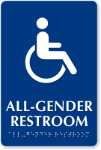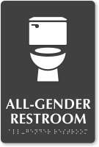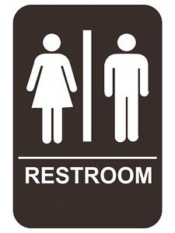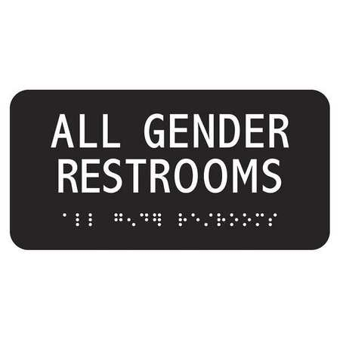

Note: ISA does not require tactile lettering below.

Signs such as the ones below would not be allowed due to the fact that they are either difficult to read or are considered by some as offensive.

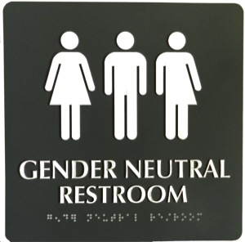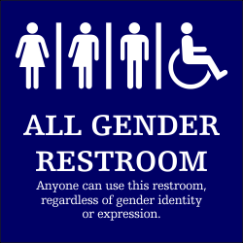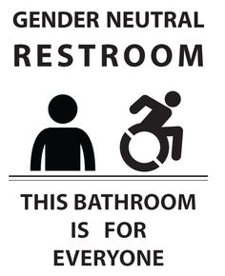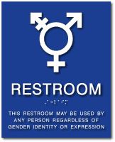

For more information on best practices for tactile signage, please contact the Department Building Inspection, Technical Services Division at (415) 558-6205 or Techq@sfgov.org.

For information regarding tactile signs, you may also consult with such organizations as the San Francisco Light House for the Blind and Visually Impaired at (415) 694-7349 or MADLab@lighthouse-sf.org .

For questions and further information on what is considered acceptable language for all gender restroom signs, please consult with the transgender law help line at: http://transgenderlawcenter.org/help or (415) 865-0176 ext. 308.

C. PROCEDURE FOR DBI INSPECTORS:
Complaints and inspections are to be handled through the existing BID field inspection and Code Enforcement staff.

___________________________________________________
Tom C. Hui, S.E., C.B.O. Date
Director
Department of Building Inspection
Attachment: San Francisco All Gender Restroom Ordinance Brochure
This Information Sheet is subject to modification at any time. For the most current version, visit our website at http://www.sfdbi.org

Frequently Asked Questions

1. When do I have to comply?
Existing single user restroom facilities will be required to replace any gender specific signage no later than August 18, 2016.

2. Do all restrooms have to comply?
No, only single user restrooms must comply. A single user restroom is defined as having one toilet, or one toilet and a urinal and designed for use by nor more than one occupant at at time.

3. Do I have to upgrade my restroom to be compliant with the ADA?
No. There is no construction required by this ordinance other than changing signage to indicate that the restroom is open to all persons.

4. What will happen if I don’t comply?
If the Department receives a complaint that an existing business is unaware of the Ordinance, a correction notice will be issued and the owner will be given instructions on how to comply. If it is determined that the business has knowingly not complied with the Ordianance, a Building Inspector will issue a notice of violation (NOV) and code enforcement proceedings will ensue.

5. Where can I get the signs and how much do they cost?
The signs are very common and available at most hardware stores, online, or through commercial sign companies, as well as organizations such as the LightHouse for the Blind and Visually Impaired.

6. Doesn’t California require separate sex restrooms?
This Ordinance is consistent with the California Building Code. Similar legislation is currently moving through the State legislature. See AB 1732 (Ting).

7. Do I have to hire a contractor to install the sign?
No, anyone may install the signs. We would ask that the person doing the work to check the mounting instructins on DBI’s website to insure that the signs can be used by persons with sight disabilities.

8. Do I need one of those signs with the half male half female ?
No. In fact, such signs are not recognized by the Division of the State Architect and they are disfavored by many persons within the LBGT community for various reasons. The Department will request that they not be installed and will require them to be removed if a complaint is filed. A standard unisex sign or a sign with a simple “All-Gender” or “Gender Neutral” as depicted in this brochure should be used instead. The circle and triangle should be plain with no raised lettering or braille, as these are not allowed upon a door by code.

9. How can I get more information on this?
You may find further information at the Department of Building Inspection’s website:
http://sfdbi.org/information-sheets/DA-016
You may also call the Technical Services Division hotline at 415-558-6205, leave a message with your questions and a representative will return your call within 24 hours.

San Francisco
All
Gender Restroom
Ordinance

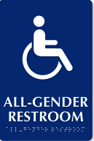
Mandatory Changes in Single-User Restroom Signage

Introduction
In order to protect the rights of all San Francisco’s residents, and to reduce gender identity discrimination, the San Francisco Supervisors have passed a new ordinance that requires all new and existing single-user toilet facilities to be designated as all-gender and available to persons of any gender identity.
Per Ordinance No. 53-16, within 90 days from the effective date May 22, 2016, all new and existing single-user toilet facilities in any business establishment or place of public accommodation* that are open to the public or employees shall comply.
Existing business establishments must remove any gender specific signage from the toilet facility and replace it with signage for all genders that complies with the California Building Code or the 2010 ADA Guidelines for Accessible Buildings. See Section 11B-216.2, 11B-216.3 and 11B-216.8.
New business establishments with single user restrooms and new single user toilet facilities within existing establishments must provide code compliant all-gender signage at the time of design and construction.
For requirements applicable to City-Owned or City-Leased buildings, please contact the Mayor’s Office on Disabilities at (415) 554-6789.
*Place of Public Accommodation is defined within Chapter 2 of the California Building Code and in the American with Disabilities Act, and generally speaking is a business where the public will enter the building to obtain goods and services such as hotels, banks, retail stores, health clubs, restaurants, repair shops, office buildings, day care centers, theaters etc. (See Section 55.52 of the California Construction-Related Accessibility Compliance Act and 42 USC Section 12181(7) of the Americans with Disabilities Act of 1990, as those Acts are amended from time to time.)
Single-User Toilets
The Ordinance only mandates a signage change for toilet facilities designed for a single occupant or family/assisted use. A single-user toilet facility means a private toilet facility with a single water closet (toilet) and sometimes a single toilet and a urinal. In the case where there is both a toilet and a urinal, there must not be a compartment enclosing the toilet; which would allow for two occupants to use the room simultaneously. The Ordinance does not have any requirements for multiple user facilities (except within city buildings), but does allow a business to designate such facilities for all genders.
Signs
There are basically two types of signs required at toilets.
1) California requires a geometric symbol on all toilet room doors or entrances per CBC Section 11B-216.8.
        - The symbol required by this Ordinance would be the “unisex” circle and triangle symbol outlined in CBC 11B-703.7.2.6.3.
        - This sign must be mounted between 58 and 60 inches above the floor to its centerline and must be within one inch of the left to right center of the door.
        - The circle must contrast in color (light on dark or dark on light) with the door and the triangle must contrast with the circle.
        - This sign should have no raised characters or symbols upon it.

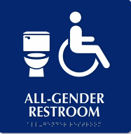
2) Both California and the ADA stipulate that any sign identifying permanent rooms and spaces shall be tactile (read by touch) per CBC Section 11B-216.2.
- These signs may be visually read, but must have raised characters and braille for use by blind and sight impaired persons.
- The signs may also have pictograms such as the man or woman characters, but there are currently no code approved all-gender pictograms.
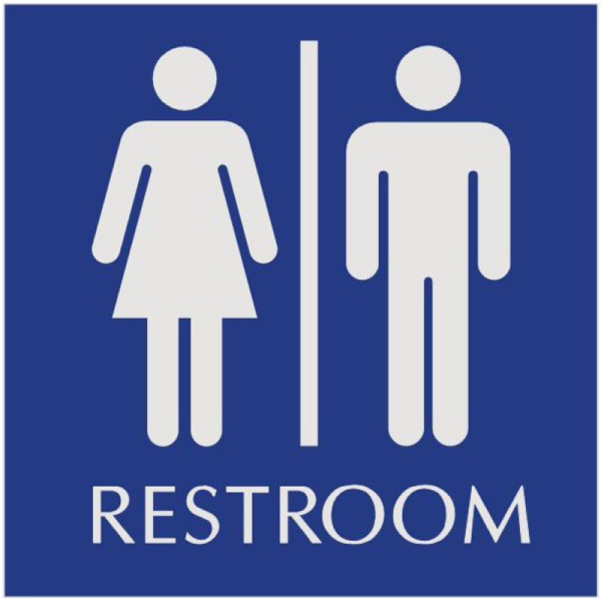
- A unisex sign or a sign such as the ones pictured on this brochure would allowed. Please keep these signs simple.

Note: Some commercially available signs for purchase are not code compliant and may be considered offensive by members of the LBGT community. Also note that if you have pre-existing “unisex’ signs (see adjacent picture) or only the circle and triangle and no gender specific signs, you are compliant with this ordinance and do not need to change the sign. For questions please email techq@sfgov.org and use subject line “SIGNS”.

